**12) BigQuery – Use BigQuery to create machine learning models ?**

Refer the website : <https://www.qwiklabs.com/focuses/1794?parent=catalog>

Step 1 : Click on the below direct link to bring the public data-to-insights project into BigQuery projects panel :

<https://console.cloud.google.com/bigquery?p=data-to-insights&d=ecommerce&t=web_analytics&page=table>

Step 2 : Table created

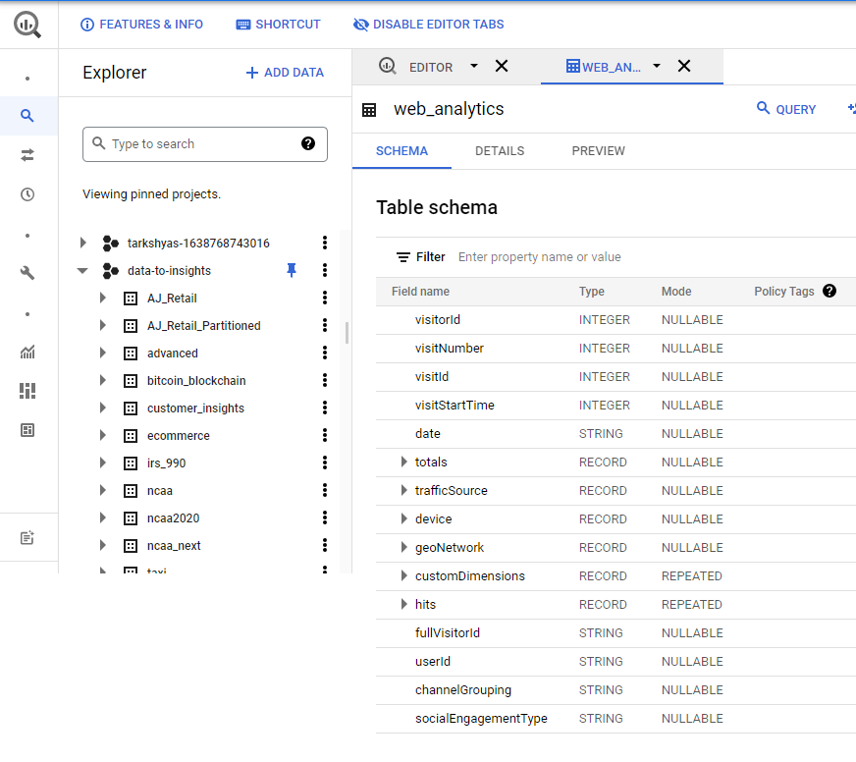

Step 3 : Run queries based on different scenarios

**Question 1:** Out of the total visitors who visited our website, what % made a purchase?

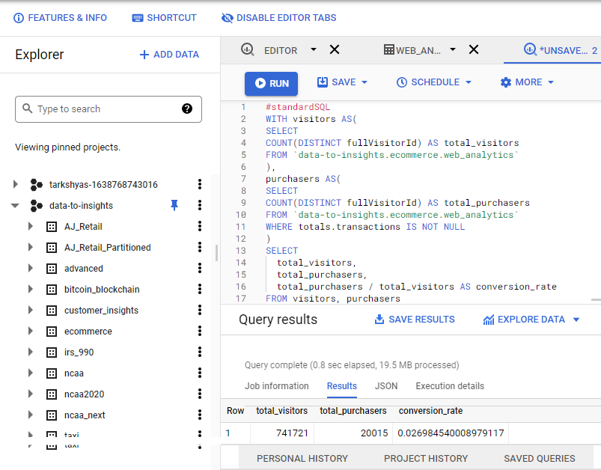

**Question 2:** What are the top 5 selling products?

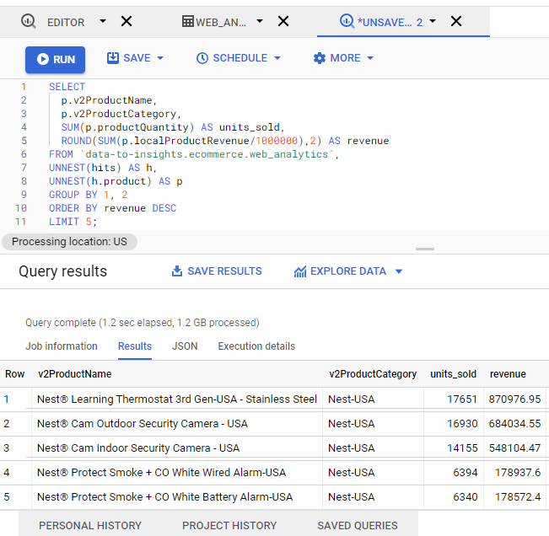

Step 4 : Create ‘ecommerce’ dataset to store models

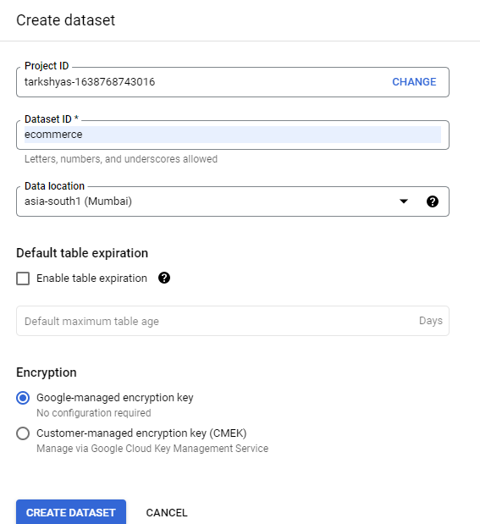

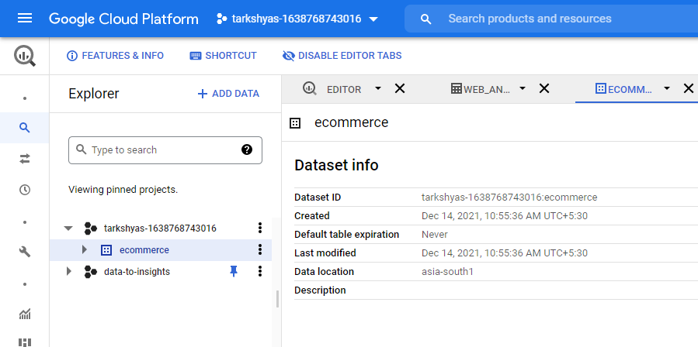

Step 5 : Now we can use logistic_regression in a classification model.

Write query to create the model and specifies model options. Run this query to train the model.

